Identification of an unknown organic compound
Name:
Institution:
Prof:
Due date:

Identification of an unknown organic compound
Abstract
This experiment was aimed at understanding the use of melting point and NMR and IR spectroscopy to characterise an unknown organic compound, and calculating Rf value and TLC information to identify unknown compound. NMR and IR spectrums of unknown compound were drawn and peaks identified. Straining using TLC plates and stripes were done to help identify the compound and calculate R_{F} that was found to be 0.799 (DSM).
Experimental procedure
The experiment was done in sections. In section 1, an NRM spectrum was collected as instructed by the demonstrator. A 10gms of the unknown organic compound sample was added to 1mL of deuterated chloroform. With the help of the demonstrator; the NMR of this sample was prepared, collected and exported and was printed and pasted on the lab manual. We moved to experiment section 2. In this station, the melting point of the unknown sample was determined for comparison with literature values. The data was recorded on the data sheet and all possible compounds in the temperature range 5-6 degrees were noted down.
Next, in station 3, with the aid of the demonstrator the IP spectrum of the sample was collected and exported electronically, printed and pasted in the lab manual. The major peaks in the lab were noted in the notebook and the possible identity of these peaks was noted. The spectrum was downloaded and plotted on excel. Afterwards, in section 4, with the help of the demonstrator, the TLC plate was set up and set for the purpose of visualizing the plate using the UV light and strains. The compound was tested with a series of Chemo selective stains. 3 grams of the compound sample were weighed out into a scintillation vial and dissolved in 3mL of acetone. A single stripe of TLC was then cut into four stripes and using the TLC spotter, the sample was spotted onto the end of each of the four TLC stripes. One of the spotted stripes was observed under long wave and short wave UV light in the TLC Light Box and the observations noted. Next, a stripe was taken and stained with the first of TLC stains and the straining process was repeated on all the remaining TLC stripes. Observations in terms of which functional groups were present or absent were recorded. Two analyses on TLC on the unknown were carried out and with an appropriate reference sample; the unknown sample was spotted on the TLC plate. Identified possible candidates from chemo selective staining and from previous stations were run as reference samples. 10% (v/v) methanol I dichloromethane (5mL) was used to eluent while waiting for the TLC to run and a second test was done with 100% (v/v) dichloromethane as the eluent. The stain identified in the first par was used to visualize the TLC and the TLC was sketched on the results sheet and the solvent system used was recorded too. The TLC cardboard that was contaminated with broken glass was safely disposed in the waste bin. The Rf value was calculated.
Results and discussion
The Unknown number was 302
Melting point of the unknown compound 50°C was 49 – 51 °C
Compound within the melting point revenge include; 4-Bromoacetophenone, and 4-Chlorobenzaldehyde.
; 4-Bromoacetophenone have IR absorptions associated with both the O-H and the C-O stretching vibrations; O–H stretch, hydrogen bonded 3500-3200 cm⁻¹ and C–O stretch 1260-1050 cm⁻¹ (s)

RF: 0.8 (DCM)
Table for main Peaks of the NRM spectrum
Chemical shift (pmm) | Normalized intensity
9.97 | 0.97
7.96 | 0.40
7.77 | 1.00
7.57 | 0.73
7.39 | 0.25

NMR spectrum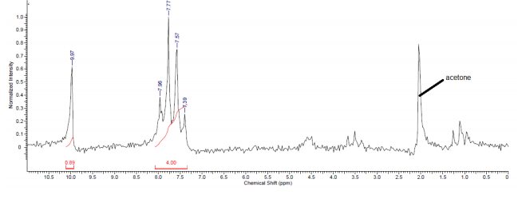
IR spectrum:

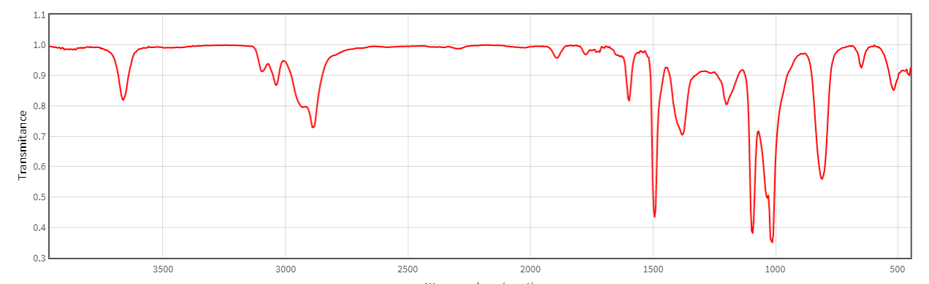
The IR spectrum that absorption peak responsible for carbon – oxygen double bond C=O of the carbonyl group is at 1700cm^-1 it is a sharp peak and this is so because it does not participate in intermolecular bonding of hydrogen.
The structure of 4-Bromoacetophenone is as shown below;
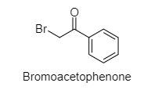
Calculated Rf= 0.799 (DSM)
This value is close to the literature value which is 0.8 (DSM). The calculated value has an error of
(0.8 – 0.799)/ 0.8 *100 = 0.001*100 = 1%
Conclusion
The unknown compound is 4-Bromoacetophenone based on its temperature and Fr literature values and functional groups obtained from the strained TLC plates.

